Configuring or re-configuring the analytics database. ‘Configure’ in this context means to create the analytics DB on your production server.

On the server where you installed the analytics package, find the analytics folder. Probably it is at
C:\Program Files\Digital Gateway\da (the default folder)
unless you changed it at time of install. You might also find it at
C:\Program Files (x86)\Digital Gateway\da
depending upon the age of your server.

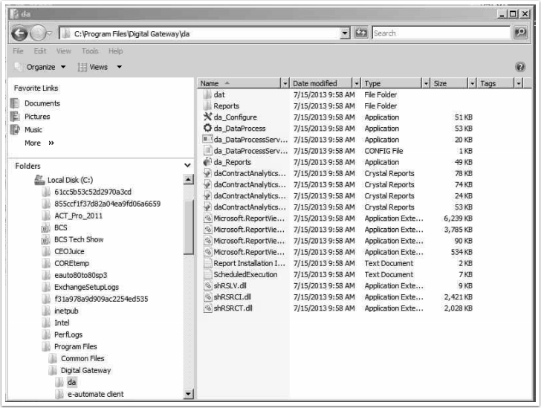

You executable you want to fire is called da_Configure.exe. When you run it for the first time you may have to set the Profile (it will sometimes inherit this information from the e-auto install on the same server, but not always). Your screen will probably read ‘8.1.0,’ not ‘8.0.0’ as in the screenshot.

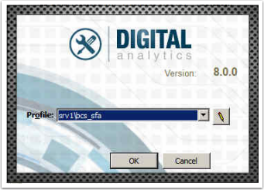
Hit ok, and you will see a screen like below.
Immediately following are instructions for configuring a new analytics DB. If you first need to de-configure an existing analytics DB see the additional steps at the bottom of the walkthough, then return to this point.

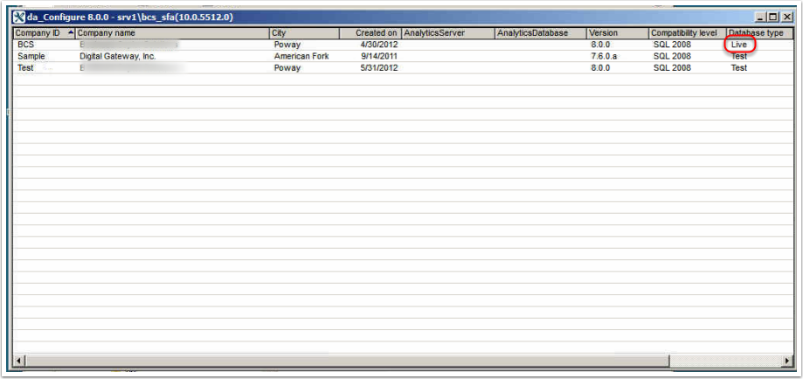

Right-click the line showing your LIVE e-automate database (you probably know the name, but if you’re unsure you can look in the right-most column). You’ll then see this:
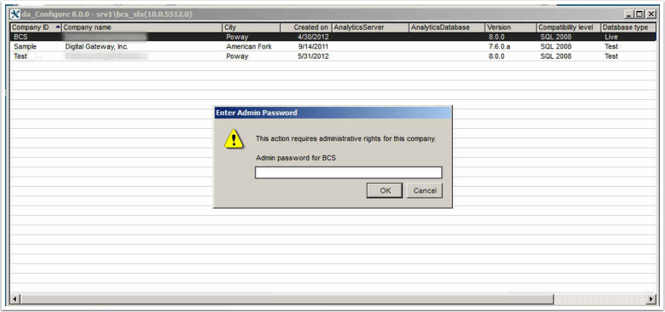
The password required here is the one you would use to log into e-automate as the user named ‘admin.’ You cannot choose to use another. Once you have entered the password you’ll see something like the below.
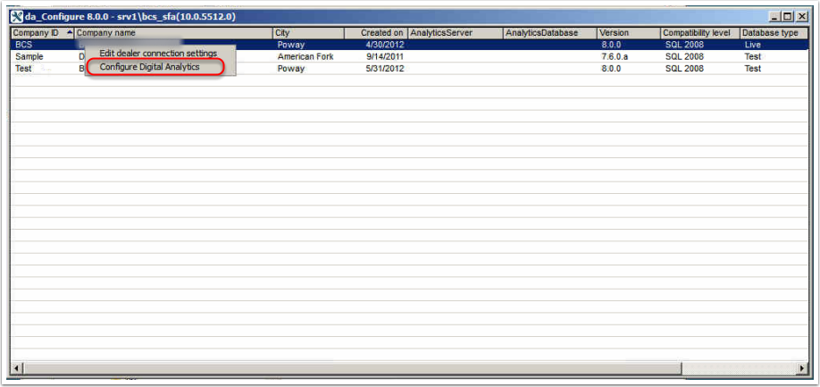
After selecting ‘Configure Digital Analytics’ you’ll see a confirmation screen as below. Do not enter of change any information, simply hit [OK].
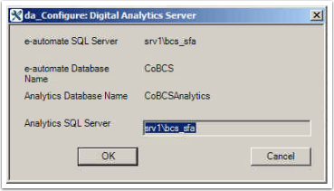
Configuration will probably take a couple of minutes. When complete, the confirmation screen will disappear and you’ll see something like the below which indicates the analytics DB is now in place.

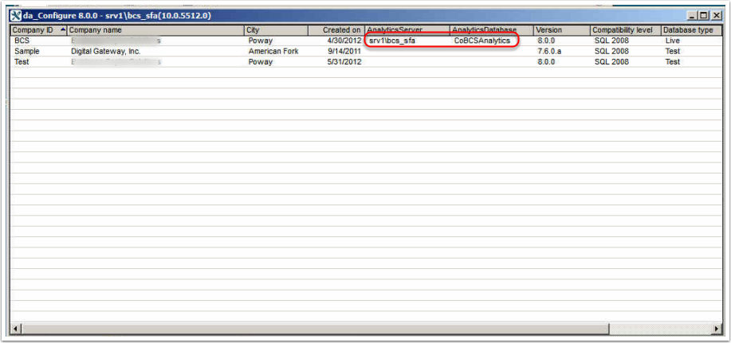
Assuming you are a CEO Juice client, please immediately go into SQL Server Management Studio and make the ceojuice SQL user a DBOwner of this new database. This is required in order for our software to access the data for our alerts and reports. We have a separate walkthough explaining how to do this.

You may want to go ahead and immediately fire the table build process, which takes all the transactional data in e-automate and populates the analytics tables. We recommend this be done after-hours as it can take a couple of hours and use a lot(!) of your SQL Server’s horsepower, leading to poor performance for other things using the same resources. The table build can also be aborted by too many users in e-automate entering or altering records during the process. To fire the table build go back to the directory specified near the top of the walkthrough and fire da_dataprocess.exe. Enter any valid set of e-automate credentials and confirm.

De-configuring an existing analytics DB (required if it becomes corrupted, or if you move from one major e-auto release to another (for instance converting from e-automate 8.0 to 8.1) In theory converting up to a new service pack should not require a re-configuring).
Proceed to the screen below, as per the walkthough points above. Right-click your LIVE database, enter your admin password and you will see new options as shown. Select Deconfigure Digital Analytics.

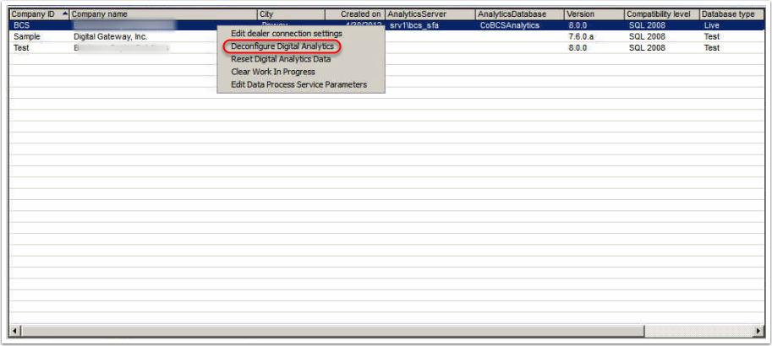
You will see a confirmation screen as below. Select [YES] and the software will proceed to completely remove the existing analytics DB. Once this is complete you may return to the steps above and configure a new analytics DB.
