The below assumes a fresh install of v2 analytics (no analytics DB already in place), either because you’ve never had it installed or because you’ve gone into your system and removed the previous install so that you can ‘start from scratch.’ Conversion from 7.60, 7.65 or 8.0 (any Service Pack) to 8.1 requires a complete re-install of analytics. Once you’re running 8.1 you should not need to re-install when installing new Service Packs (or, at least, that is the latest information we have from DGI) unless and until e-automate 8.5 is released.
The below (and our other v2 analytics walkthroughs) assume you are connecting to the e-automate server and to SQL as a administrator with full rights and privileges.

See <SEPARATE WALKTHROUGH> on dropping existing analytics DB and uninstalling if that is required.

Unzip the installer package provided by DGI onto your production server (the server hosting your e-automate DB) and execute it. The filename is ‘DigitalAnalyticsSetup,’ it will probably be the only file in the zipped folder. Depending on the credentials you logged into the server with, you may have to right-click and select Run-As-Administrator but ideally you will be logged into the server with the Admin credentials.
You will cycle through the following screens, accepting defaults except as noted.
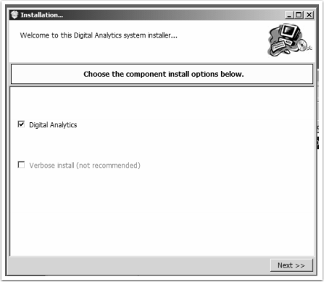

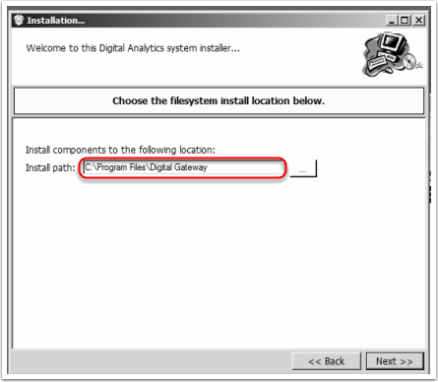
NOTE: You may select another destination folder, but be advised that the files involved total only about 26 Mb. This folder must be on the production server and freely accessible.
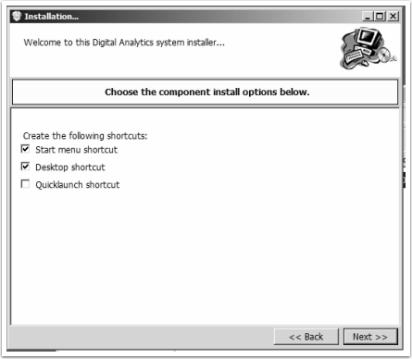
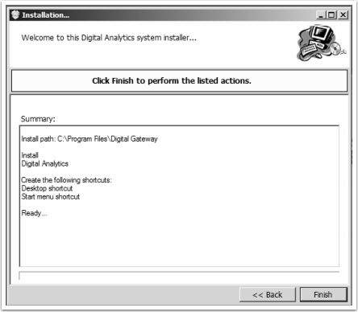

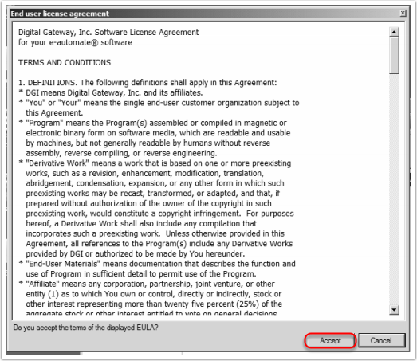
NOTE: Be sure to read this thoroughly, just as you do with every other piece of software you install…

The screen which follows requires you to enter several pieces of information, per the notes below the screenshot.

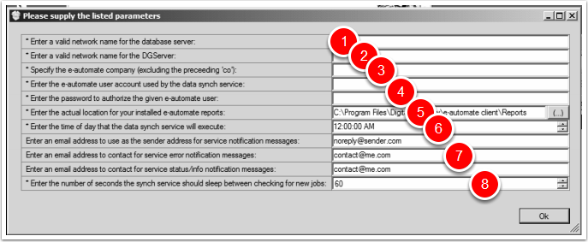
- The name of the Database Server where e-automate runs. See appendix A on how to ‘steal’ this information from SQL Server Management Studio or the e-automate client.
- The name of the DGServer (SQL Server) e-automate is running on. See appendix for help with this, too.
- The e-automate Company you’re wishing to build an analytics database against. The appendix covers this also.
- The table update process will essentially log into e-automate every night in order to fire the update processes. For this reason you need to specify a valid set of e-automate credentials for the Company in question per #3. These need to be credentials which do not change as the update will be using them nightly and if you change the password or delete the e-automate user the tables will no longer update. Alternatively you will need to remember to change settings inside the analytics package whenever the password changes (e-mail us for help with that, there are easier ways than just re-installing from scratch but I haven’t created that walkthrough yet).
- This is the file location where the installer will save the ‘stock’ analytics reports DGI provides. You can choose to specify your shared Reports folder, or you can select another location and then manually copy them (or copy them to the individual workstations you want to run the reports from, if you’re not using a shared Reports folder). These reports, once installed, are run directly from e-automate.
- The nightly table update will take on average 5-15 minutes to complete and needs be scheduled at a time when no routine downtime or maintenance is taking place. We find that 2a works well for most clients, but make sure you choose a time with no scheduled conflicts.
- Here you can specify e-mail addresses and be automatically advised of issues with the routine updates of the analytics tables. Feel free to set these e-mail addresses but in our experience the automatic notification process is not very reliable. For that reason we have an alert (ID459) which monitors the analytics tables and advises CEO Juice of any issues. You may feel free to add yourself on copy to that alert via the subscription.
- This is how often the Windows Service will check for new work (check to see whether it’s time yet to fire the update). We recommend it stay at the default ‘60’ and that it not be changed to anything greater than ‘600’ (which is the longest setting we’ve tested).

When all information is entered press OK and the installer package will actually begin the work of installation. You will see progess reported onscreen. When it is complete you will see a DGI flash screen pop up. The analytics package is STILL WORKING at this point, please do not interrupt or attempt to close the installer. When work is complete you will see a second, smaller pop-up which either indicates that the analytics DB is ready to be configured (hit OK to allow it to continue) or that is was already configured (in the case of an upgrade as opposed to fresh install). Allow time for the new DB to be configured if that’s required, then you’ll see an additional popup indicating it’s complete. Once you see that popup you can hit OK to close it, then close the installer window as below.
If you see an error at this point (while trying to configure the DB) you may be required to configure it manually. See <SEPARATE WALKTHOUGH> on how to do that.
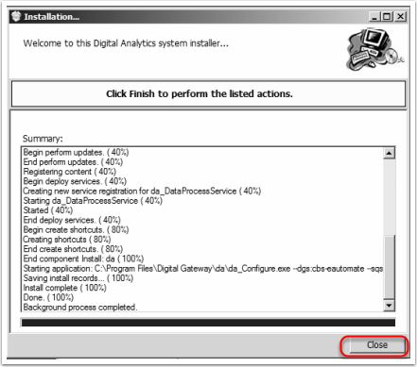
You now need to configure the Service which will fire the automatic table updates. Go to the Services window and find the Service named da_dataprocessservice as below.
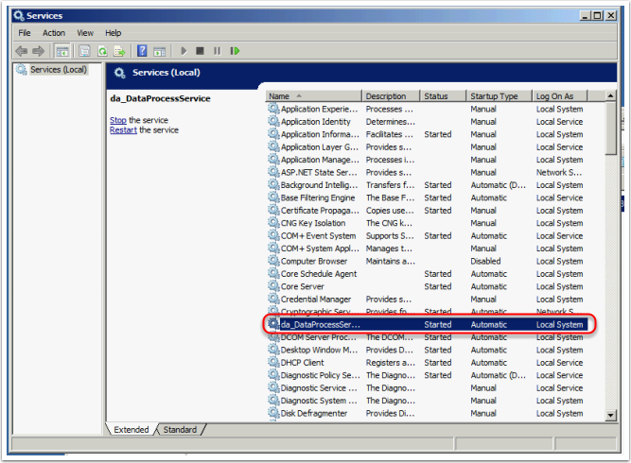
Double-check the Service and go to the Log On tab, as below. Select the ‘This Account’ radio button and specify the same credentials you are currently using to log into the e-automate server. We have found that the Local System Account will not reliably for the executable, and that you need to specify a user with sufficient credentials. By using the same credentials you’re currently logged in under you guarantee that the Service will have sufficient permissions to work effectively.
You will have to stop and re-start service for the changes to take effect.

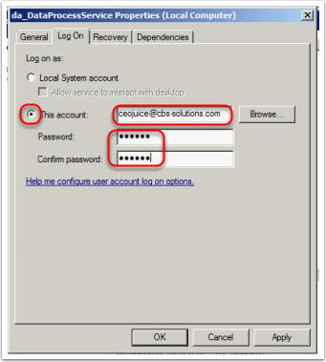

Now you need to fire the initial table build of the analytics DB. This is an involved process that often takes about two hours and uses significant horsepower on your e-automate server. We recommend that it be done after-hours, a good solution is usually to fire the table build just before you leave for the day and check on it first thing next morning. The table build must run when all users are out of the e-automate client (or, at least, not actively doing anything. Actual log out by all users should not be required).

Go to the folder you installed the analytics package to per #5 in the settings screen above. Find the executable named da_DataProcess.exe and fire it, as below.
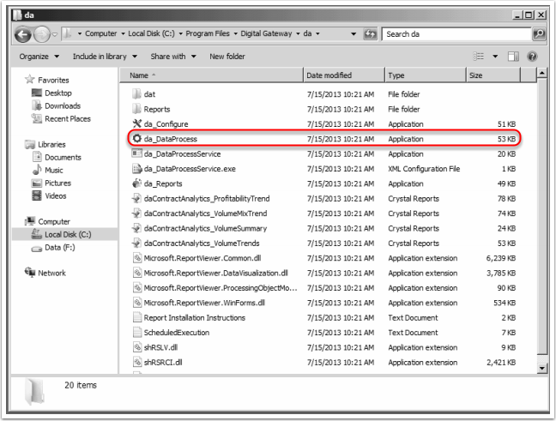

Enter the same credentials you entered in the analytics settings in #6 above, and hit OK. You’ll see an additional ‘are you sure’ screen, select YES and the initial table build will begin. When it is complete you will see an additional popup indicating success and telling you how long the process took. Automatic table updates WILL NOT proceed until you hit OK on this final popup, so please make sure you check back the next day and confirm that the table build was successful.

Once you have confirm the initial table build please advise CEO Juice of this fact. We need to install several things on our end so that you can begin to use our analytics-powered alerts and reports, and we also need to install or update ID459 so that we can monitor your analytics DB and advise of any problems.

APPENDIX A
Getting DB information from the e-automate client.
Start by opening up e-automate as though you were going to log in. click the PencilEdit button as marked in red. Make certain you have specified a valid User ID.
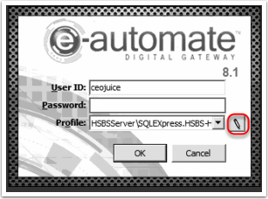

Double-click (or EDIT with the button) the profile for your LIVE e-automate DB.
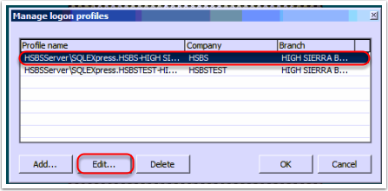

#1 below is the SQL Server, to match #1 above in the screenshot showing how to enter settings when installing analytics.
#) below is the DGserver, to match #2 above in the screenshot showing how to enter setting when installing analytics. If you see ‘:1331’ appended (as below), DO NOT COPY THAT PART when entering the settings. In the example below, the correct DGServer setting would be ‘HSBSServer’ and NOT ‘HSBSServer:1331’.
After copying that information, click NEXT to continue.

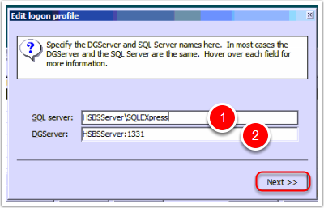

Select the Company Name for your LIVE e-automate DB from the dropdown provided. This is the Company to match #3 above in the screenshot showing how to enter settings when installing analytics. You cannot cut/paste, you will have to manually enter this information into the field.
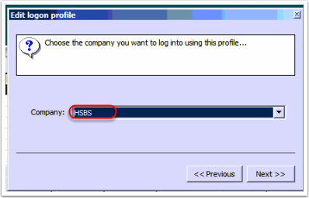

Getting DB information from SQL Server Management Studio.
Open up SSMS and connect to your e-automate SQL Server. You’ll see something like the below.

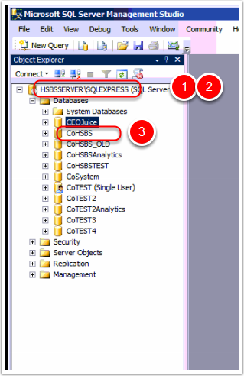
The SQL Server, to match #1 in the screenshot showing how to enter settings when installing analytics, is the entire string. In this example the correct SQL Server setting is ‘HSBSServer\SQLExpress’. There may or may not be a ‘\’ and a second string of text following.
The DGServer, to match #2 in the screenshot showing how to enter settings when installing analytics, is the part of the string BEFORE THE ‘\’, assuming there is one. In the example above the correct DGServer setting would be ‘HSBSServer’.
The Company name, to match #3 in the screenshot showing how to enter settings when installing analytics, is the name of your live e-automate DB NOT INCLUDING THE PREFIX ‘Co’. In the example above the correct Company name would be ‘HSBS’.

