Restricting Application Permissions to Specific Mailboxes
The Graph API only allows all or no mailboxes. However, Microsoft released documentation to limit registered applications to specific mailboxes listed here.
To help assist implementing least privileged access, we have provided guidance for setting up a new mail-enabled security group listed below.
Note: You will need the Exchange Online module in PowerShell. See here to add the module to PowerShell and here on how to connect.

- Navigate to the App Registrations page within Azure and click on the Meter Email Parser registration. Identify the Application Client ID in Azure.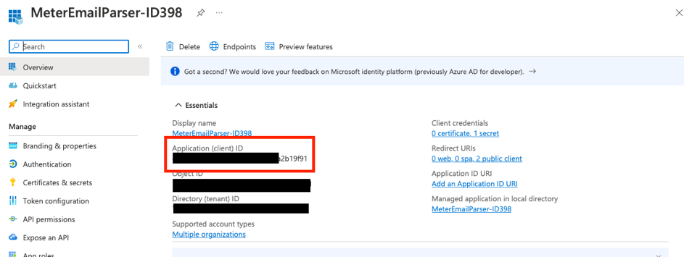

- Log in to Microsoft Office 365 Exchange Admin Center and navigate to Groups.

- Create a new mail-enabled security group or use an existing one and identify the email addresses to be included.
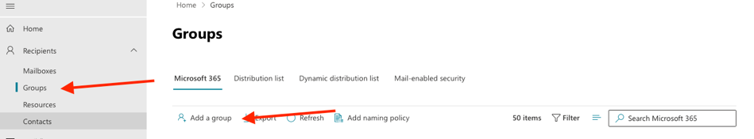
  - Select Mail-Enabled Security group
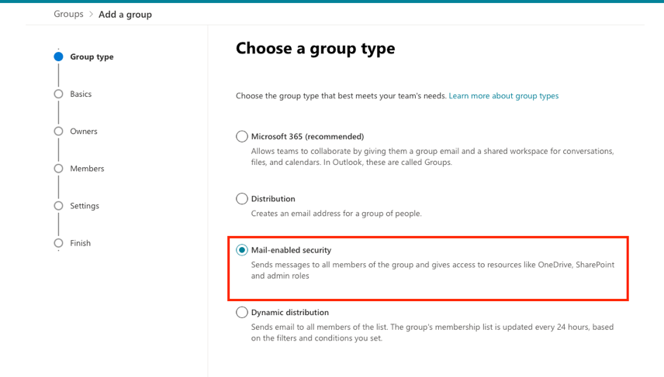
  - Give it a name, preferably one that would help identify that group later. Assign an owner to the group.
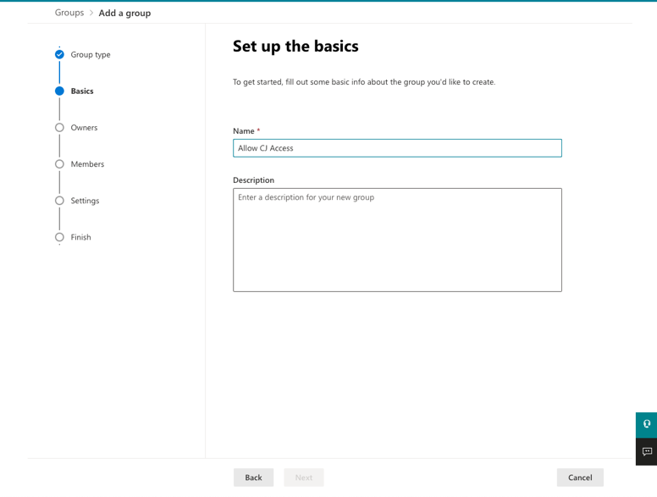
  - Add the mailbox(es) which requires access.
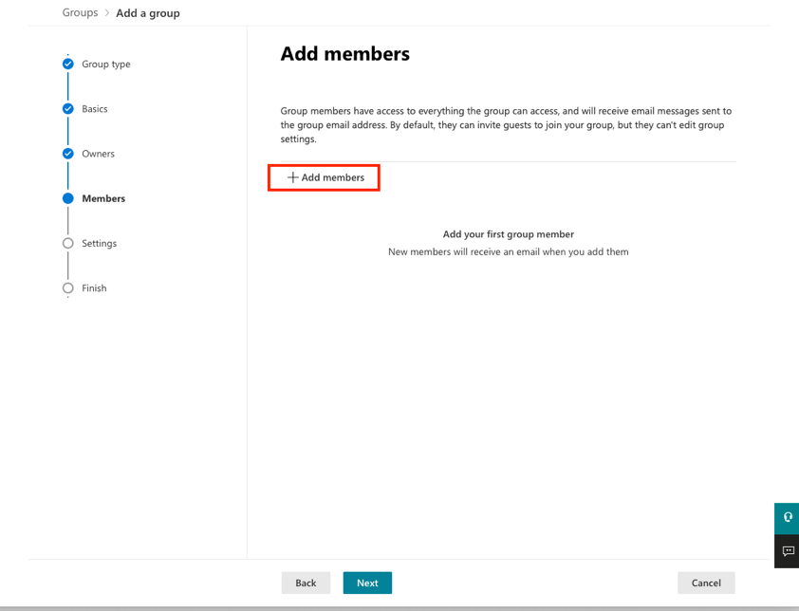
  - Give the group an address.
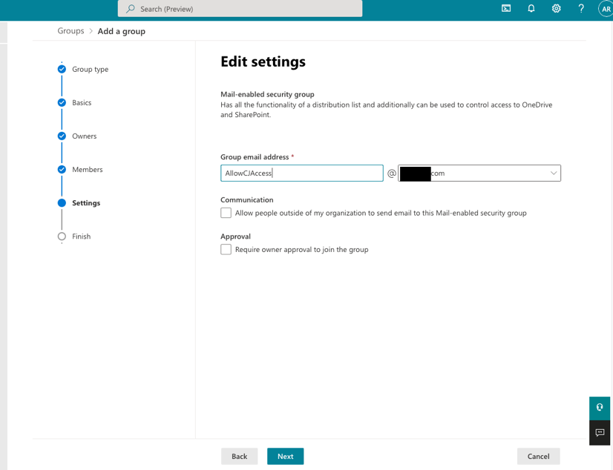

- Connect to Exchange Online via Powershell.

- Run New-ApplicationAccessPolicy -AppId XXXXXXXX-XXXX-XXXX-XXXX-XXXXXXX -PolicyScopeGroupId AllowCJAccess@Domain.com -AccessRight RestrictAccess -Description "Restrict this app to members of distribution group AllowCJAccess" (Replace AppID with Application Client ID / Security Group email address).

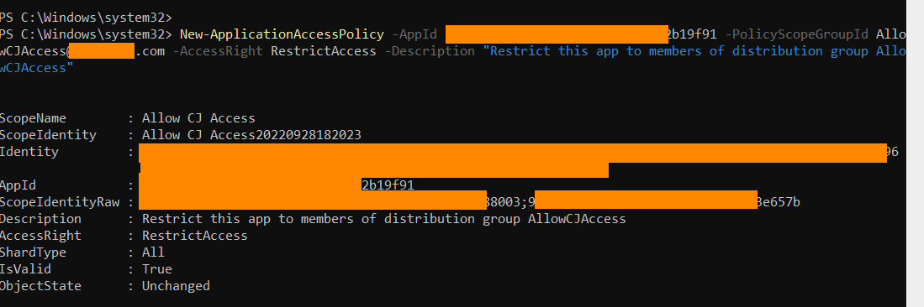
- Test Application Permissions.
Test-ApplicationAccessPolicy -Identity XXXX@Domain.com -AppId XXXXXXXX-XXXX-XXXX-XXXX- XXXXXXX
  - Note: AccessCheckResult will show Granted for mailboxes available to the application.
